1. Microservice communicate through http.
2. Monolithic, we can create a class object e.g product in user can proceed. But Microservice it’s not possible.
3. Microservice – one business logic, DDD or Single responsibility principal . Each microservice has its out bounded context.
   1. Decomposing business goals
   2. Independently deployable unit
4. Design Patterns :
   1. DPS – Data base per service design pattern
   2. MSIPH – Multiple Services Instances per host (Auto Scaling using this design pattern)
      1. If the load on one micro service increases , then we can increase number of instances i.e in GKE its pods and then exposed as a service.
      2. Each MS has its DB as per DPS , if user service is asking address service a lot of information , then to balance this load on the fly number of instances are created and traffic is deviated.

***Each MS per Data Base*** – Product micro service instances have been increased to serve more requests



Product

* 1. Aggregate Design Pattern – API Gateway

1. API Gateway –
   1. Why API Gateway - Single entry point for the users , Since each MS can have multiple instances if scaled up, which means multiple ports per instance , why should user bother about changing ports, they should only know the name of the MS to be used.
   2. 2 solutions :
      1. User will only talk to API Gateway and has to give service name
      2. Eureka Discovery : Discover the service and don’t hard code the port number , only give the name and rest configurations are done in the property files .Now API will send the request , and has to take care. Every MS has to register to Eureka as a client
      3. Load Balancing -API gateway either has a Load balancing client or can talk to an external application as well
2. Centralized Configuration Server : Config Server
   1. Problem – each MS has .properties or yaml file with different configuration set.
   2. Solution is – Config Server : All MS including discovery server i.e Eureka , can fetch the details from the centralized configuration server.
      1. Super – no need to bring MS down for updating configuration , simply can be pushed
3. Event Driven Microservices.
   1. (Message Driven or Event Driven Architecture)
   2. Asynchronous communication – Since a message is persisted in the message broker , therefore even if the subscriber/consumer goes down can process once it comes up
   3. Problem - >Client Server Model: When there are 2 or 3 microservices then request / response over http as a synchronous communication is ok , but in real world there could be dozens of micro services , which may have to communicate with each other and its not possible to wait for synchronous responses . Therefore events are most popular.
   4. Solution -> Producer Consumer Model

Producer’s 🡪 Message Broker 🡪Consumer’s

OR

PUB – SUB model

1. Transactions
   1. Monolithic – Any issue anywhere in the layer everything and entire transaction is rolled back
      1. ACID –
         1. Atomic – All rollback all commit
         2. Consistency – Data is consistent , no partial update e.g payment if one account is deducted and another is credited and all are saved in the DB
         3. Isolation -No 2 transactions can intersect
         4. Durability – After transaction is done its in the DB , and will not be reverted. Anytime I can get details , its durable.
   2. Challenges with Micro Service – ACID transaction in one MS abreast with the ACID transaction maintained between MS is challenging . Changes must be proliferated or disseminated properly between MS’s
      1. Risk at any MS transaction fails , it has to be rolled back between multiple micro services
2. **SAGA** – Solution to maintain the **consistency** **across multiple micro services**
   1. Choreography Based SAGA Design Pattern
   2. Orchestration Based SAGA Design Pattern
3. Choreography Based SAGA
   1. MS communicate by exchanging events.

Just think it as a Single transactions which consist of the multiple local transactions 🡪 E.g

Begin Transaction

Create Order - Microservice Order with its own DB

Reserve a stock – MS Inventory with its own DB

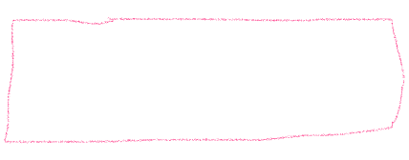 Process Payment – MS Payment with its own DB

Do Shipment – MS shipment with its own DB

End Transaction

**Important** – For the transaction to be successful , all the local transactions in individual MS’s must be successful . If one fails , all must be rolled back.

How – Now if unsuccessful – then micro service will publish an even for each previous MS to toll back transactions

Say there are microservices A,B,C,D,E,F,G

Events are denoted by e e.g eA event triggered by A

***Success Flow***

A –triggered (eA)🡪 B consumed (eA)

B –triggered (eB)🡪 C consumed (eB) … and so on , one trigger an event and the other service consume that event and trigger its event for third service .

***Rollback Flow – Reverse Order flow***

**Important point -**  Compensation Transactions must follow the reverse order.

C Rollback its changes and –triggered (eC)🡪 B consumed (eC) 🡪

B Rollback its changes–triggered (eB)🡪 A consumed (eB) … and so on , one trigger an event and the other service consume that event and trigger its event for third service to be rolled back individually.

1. Orchestration Based SAGA Design Pattern

There will be a separate SAGA Orchestrator Micro-service to track all the microservices events. Just like a manager , managing the flow of the events

**Success flow:** Manager Manages everything , there another micro servide SAGA is defined

Say there are microservices A,B,C,D,E,F,G

Events are denoted by e e.g eA event triggered by A , eSaga – is a Saga event

A create Order and trigger eA(order created)-- > Saga Service Consumes eA and trigger eSaga

🡪 B who is a listener to this will consume eSaga and will trigger eB event

* Saga will consume and will trigger eSaga event so other can consume and so on ….. So Every process is done via Saga SAGA only , it’s a kind of gateway or manager for all services

**Fail flow:** Here we have to generate **Compensation events, basically rollback events**

**All events in the reverse order now**

**This Reverse Order is also maintained by this SAGA micro service**

**Important points -**

1. Order of rollback
2. Management of the events , is done by one SAGA micro service.

**Difference**

1. Choreography – each service is responsible for rollback events publish and consumption and processing, no centralized manager.
   1. Disadvantage – but no reverse order , so need to be care to trigger the next event only post success of the previous event
   2. Advantage – fast, and each transaction is responsible to rollback.
2. Orchestration – Centralized manager is responsible to disseminating and proliferating the process of events.
   1. Disadvantage – Single point of failure, and one additional step to pass via Saga
   2. Advantage – Management is clean

1. Frameworks – Transactions can spun multiple services

2 Frameworks which make the building of transactional micro services much easier:

* 1. Eventuate Framework – Open source , and comprise 2 frameworks:
     1. Eventuate Tram – A framework which uses traditional persistence like JPA
     2. Eventuate Local – A framework which use event sourcing
  2. AXON Framework – Open Source based on DDD and CQRS design Pattern
     1. DDD/event sourcing and CQRS systems

1. CQRS design pattern:

CQRS – Command Query Responsibility Segregation

[Both have separate responsibilities i.e responsibility segregations ]

1. Command – is a trigger an Action
   1. PUT / POST / PATCH
2. Query – is a request for an information
   1. GET
3. Approaches of CQRS –
   1. Approach 1 - One Micro service everything both Command part and Query Part

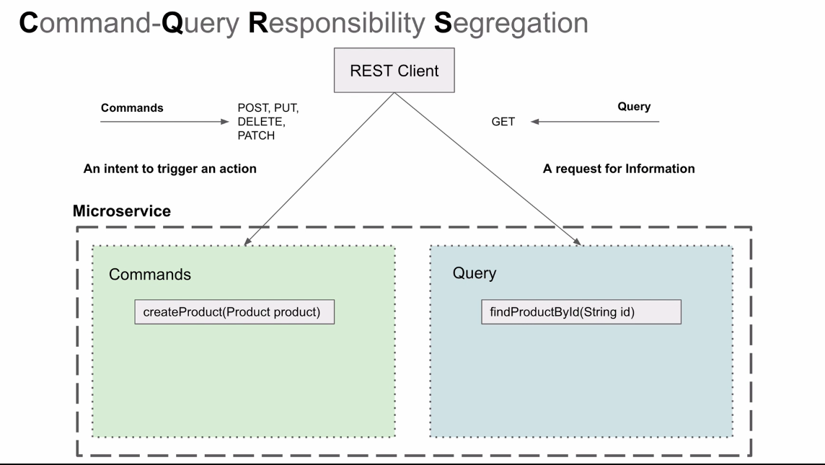

* 1. Approach 2 – There can be 2 different microservices handling the different responsibilities, MS-1 for command and MS-2 for Query. Please notice:
     1. **Command MS** has a different DB specific to cater **writes**
     2. **Query MS** has a different DB specific to cater **reads**
     3. Kunal’s Question: How to sync a DB for the 2 MS: Can we have Cassandra , columnar DB or Mongo DB for Document Database if the search queries are too many : for read and RDBMS for writes.
        1. Why columnar DB: because read can have finite query patterns, and there is ever-flowing data in the DB.
        2. Why Document DB: If the queries are many and are complex.

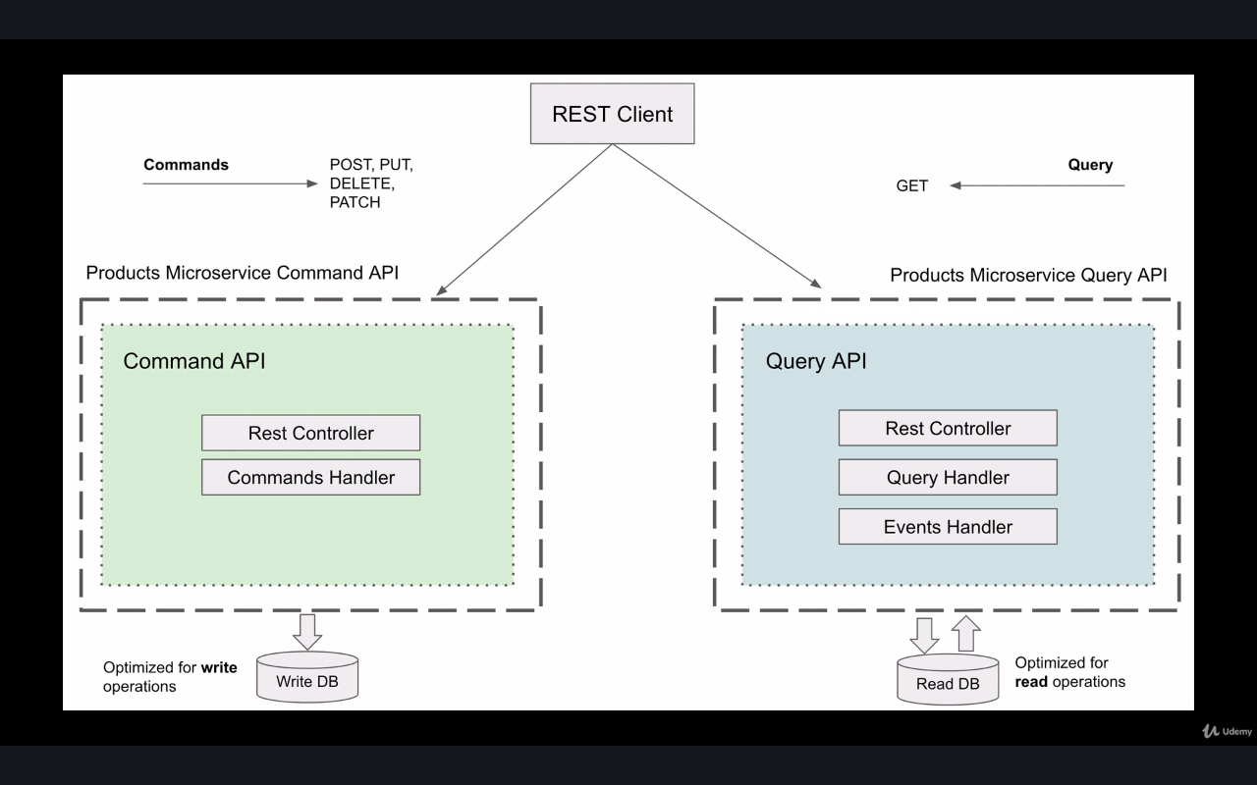

1. Kunal question :How does the data gets synced between read and write DB’s
   1. Answer – Message Broker
   2. Provides location transparency : because the micro services are located at any location so, it does not matter where the command MS is present or how many Query MS’s are consuming it . It can be placed at multiple locations also like different regions and different zones.

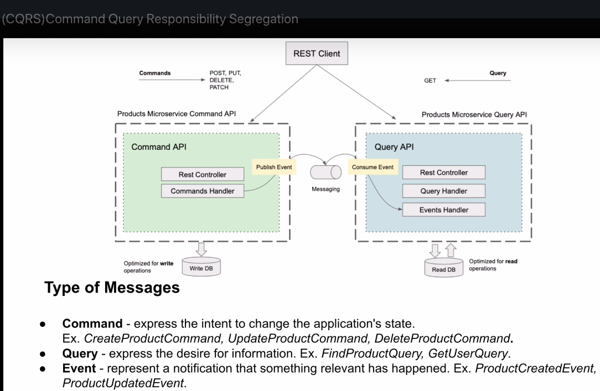

**Very Important: Type of messages in CQRS**

* + 1. Command – intention to change the state or do something
    2. Query – request or desire to get an information
    3. Event – Legitimate Notification, someone must consume an event it should have an intended recipient to take an action.

**(CQRS And Event Sourcing) – Often used together**

1. In normal case : One record is inserted in DB and , then we can update the same record in the DB. So at any point in time there will always be one unique entry in the DB for particular entity.
2. In Event Sourcing: No update occurs, each and every event is stored in the data base as a new event. **No Update – Only Insert**

|  |  |  |
| --- | --- | --- |
| **EventID** | **Event Description** | **Event Payload** |
| 1 | Event-Created | {"prodId:101,"price":10} |
| 2 | Event-Updated | {"prodId:101,"price":11} |
| 3 | Event-Updated | {"prodId:101,"price":12} |

**Actual Event DataBase i.e Write DataBase and Read DataBase**

**Note :**

1. Note carefully event store has all the events (Pay attention to Column Names Event ID,Desc and Payload) but the actual and final result is stored in the Query DB (Pay attention to the column name – its actual values).
2. From the Event store , entire Query DB can be reconstructed or can be replicated. Amazing na !!!!
3. Replay – We can create new DB with different view also from the event store , since it has all the historical events

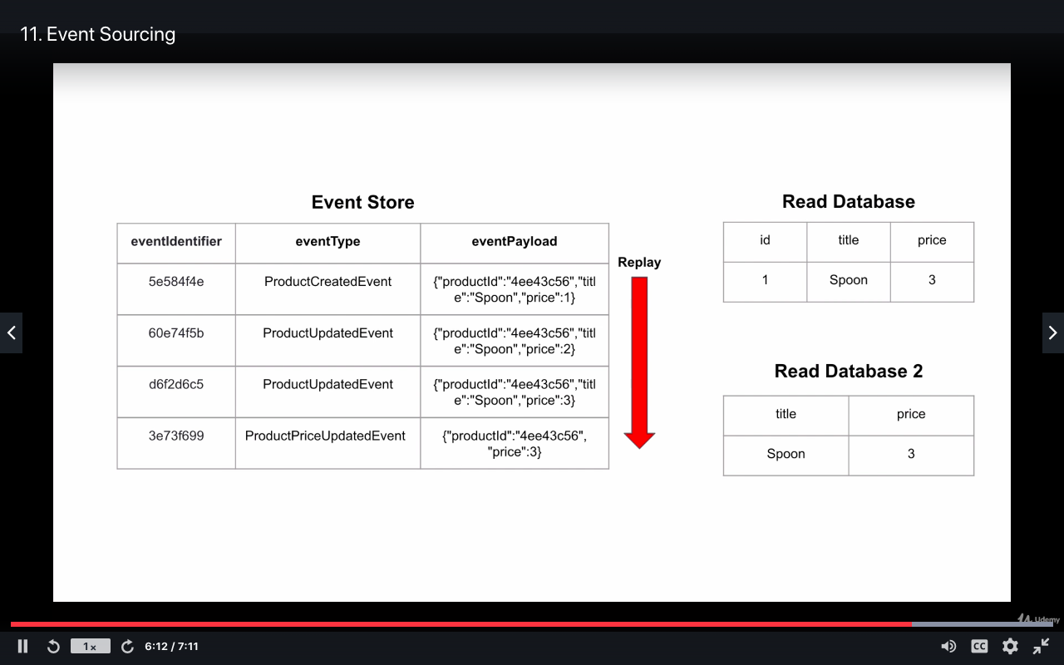

GCP Cloud Snapshots- If we feel it can be cumbersome in storing all the history and replying them , in the cloud there is a feature of Snapshot, we can also use snapshots to replay the events and no load on the actual DB.

*Just Kunal’s Thinking only may not be so relavent– May be its like SAGA orchestration , where Manager service can keep a trac of event in sequence, and can be helpful for rollback or tracking of an information*

1. Where is this event sourcing used now in CQRS design pattern?

Explanation:

* 1. Event Store – stores all the events (PUT/POST/PATCH/DELETE)
  2. Read Store – Replica and store the final output or finally updated single record i.e it stores latest updated value which is final. (GET)

1. **AXON Framework** – Its build on 3 architecture Principles
   1. DDD- Domain Driven Design
   2. CQRS – Command Query Responsibility Segregation
   3. Event Sourcing

AXON Design components high level understanding:

1. UI – Front end, basically user Facing
2. Command Handler – Who Publishes to message broker and Persists in Event Store (It can be provided by AXON or we can use any DB NoSQL or RDBMS)
3. Query Handler – Who Consumes from message broker and persists in Query DB
4. Event Store – store events and Query Store – latest Updated value
5. Below 2 parts Upper part above purple line is Command Part and Below is a Query Part

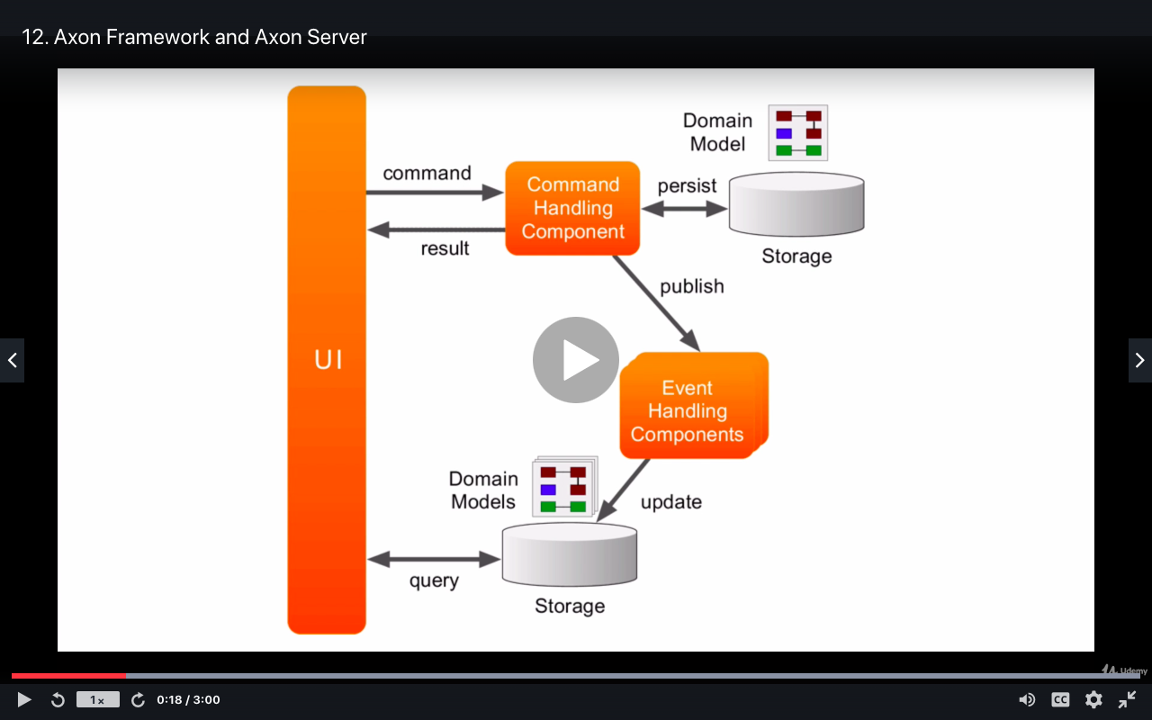

Query

Command

1. AXON is not just a framework, but it also provide the infrastructure e.g its Event Store Solution. It also invokes AXON Server
2. Basically AXON Framework, also provide infrastructure mainly AXON Server. Which do routing as well as it manages event store
   1. Axon Server – Manages all the message routers and the event store.
      1. It comes in 2 editions: standard and enterprise addition
      2. It can run in clusters and can be scaled in multiple region and zones , just like any other server.
      3. Kunal note in the AXON server we can see 3 entries , like 3 type of messages:
         * 1. Command
           2. Query
           3. Event

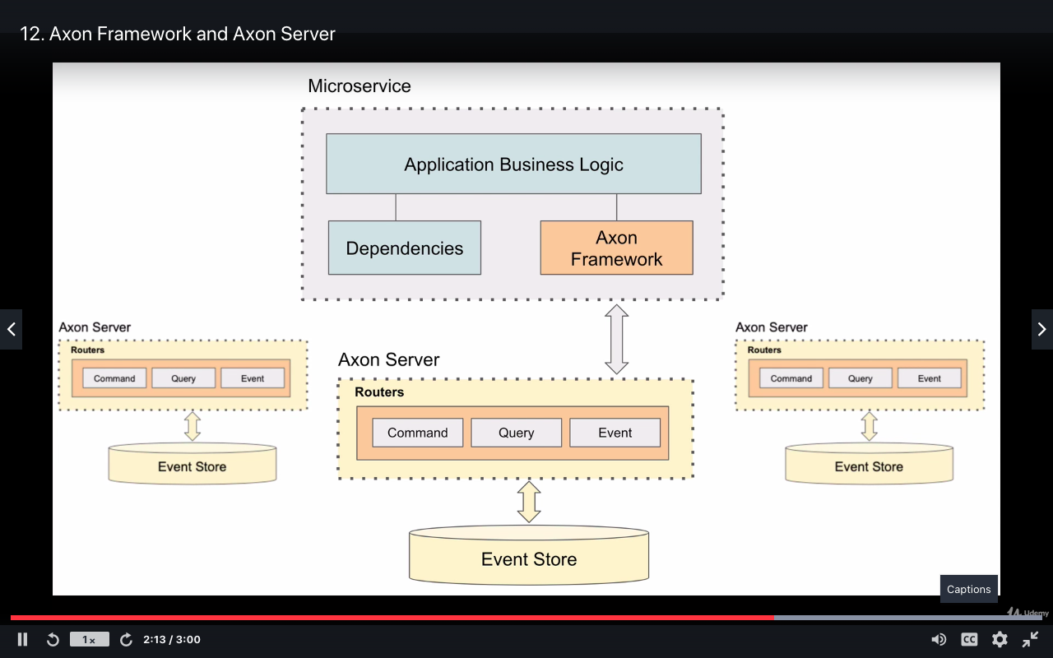

1. Just like swagger or info. AXON also has a login to check about the micro services, if all ok, health check etc
   1. We can also see live update of event store
   2. Specialized Query Language -Query can be performed to get details of the persisted events
2. Using Docker and Spring tools suit
3. SPRING TOOL SUIT Development Environment – We can use spring initializer as well as the spring tool suit to create a spring project “ THIS IS AMAZING”

New -> Spring Project Starter -> add dependencies and go………

This is really amazing , we do not need to go to spring initializer and do the configurations or download zip. In the spring suit we already have spring.initializer.io configure internally and the project is created direcly in IDE, no need to download zip and then move to other folder and then import …. Super easy

1. API Gateway:
   1. Basics – since all microservice can have multiple instances and each instance has a different port means different address , if eureka client is enabled then each of it automatically is registered with the Eureka Server
   2. API Gateway -> (Based on Aggregator Design Pattern)
      1. Built in Load Balancer : Which can distribute request between each instance of micro-services in round robin manner.
      2. Single entry point for user
      3. Fetch Address from Eureka for Load balancing : API talk to Eureka to fetch the address of each and every MS, as all are registered with Eureka . Basically, Eureka is discovery or a catalog or address book for all the MS which are registered with it.

Note : Load Balancing API only does not the Eureka , Eureka only is a single place to get addresses on which load balancing is to be applied.

* 1. API Gateway Filters : Just to filter the type of http requests allowed , we can make customer filters or we can use built in filters. Question is why do we need filters here , Use of API is ok , ***it’s an abstraction provided to customer to avoid confusion.***
  2. Filters means we can achieve:
     1. Logging: we can allow logging for specific service
     2. Validation: We can do JWT authentication for security
     3. Custom routing: http request to specific MS . We can define API routs

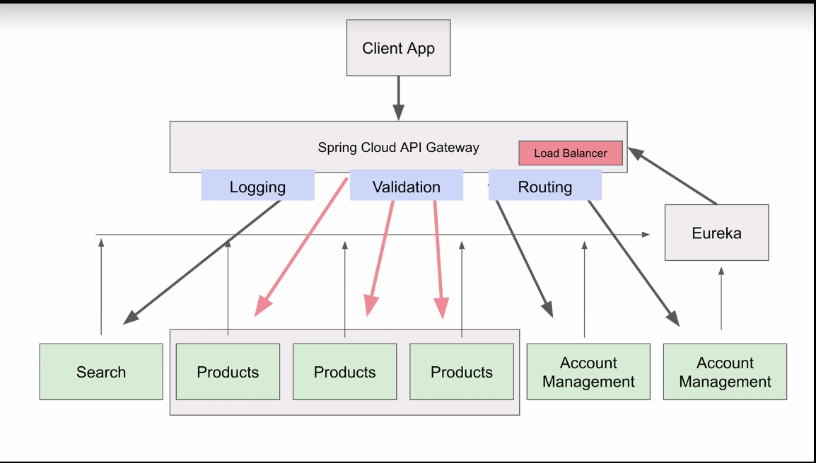

* 1. Important entries in property file
     1. **Enable Routing** : Spring.cloud.discovery.locator.enabled =true: Enable routing , so API gateway can rout http request to desired microservice via Eureka Server.

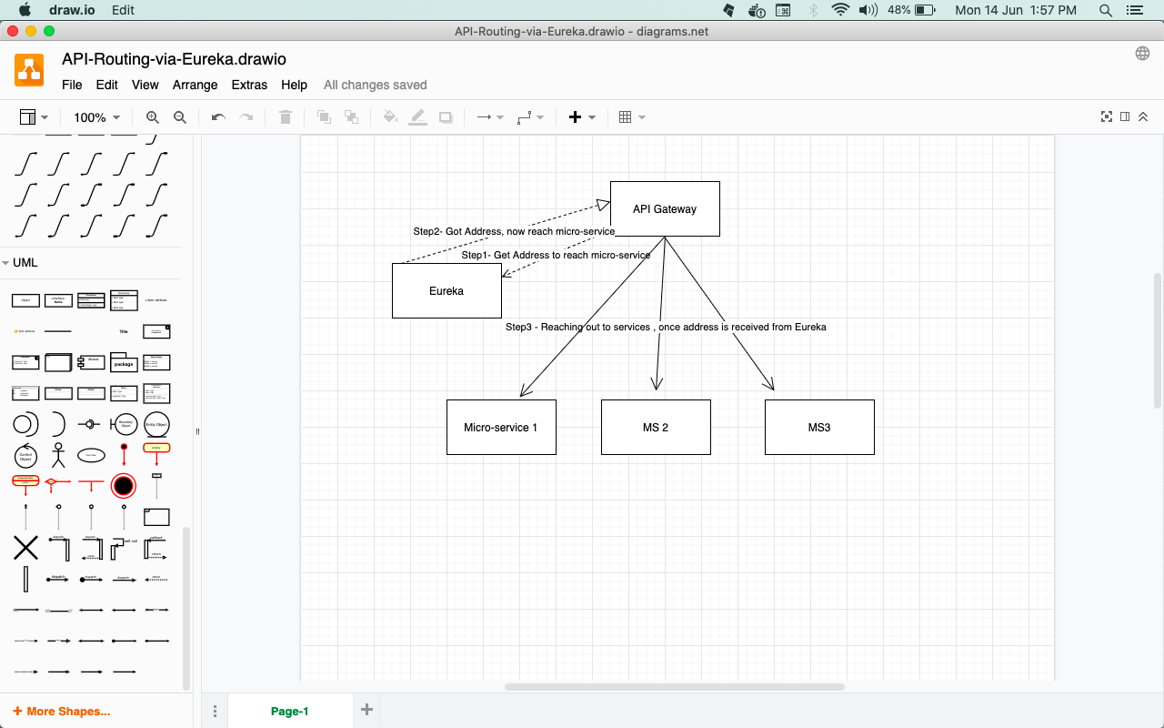

24. How to access the service using API gateway – simply add service name before the request mapping e.g

[*http://localhost:8082*](http://localhost:8082)*( apigateway port and not actual service ):/micro-service-name/urlEndPoint*

*Problem -*  “ **Using Service Name**- **This is always in the capital letter as defined in the Eureka** “

*Solution – just add the property in the property file :* spring.cloud.gateway.discovery.locator.lower-case-service-id=true

1. Randon port numbers - make “0” as an entry. This is amazing kunal

#server.port=8081

#It on the fly ramdomy a port is supposed to be choosen

# then instead of giving a port number just make it zero (0)

#Application will always choose available port number if run multiple times

# server.port=0

1. Load Balancer - Spring cloud API uses built in ribbon load balancer for client-side load balancing under Spring Umbrella

Spring Boot API

1. AXON Server Start septs:
   1. Download AXON server from : <https://axoniq.io/>
   2. We can download a complete docker image and run the same or we can download as an independent zip file and unzip it at a specific location.
   3. Fire below commands:
      1. cd AxonFolder
      2. Start Server 🡪java -jar axonserver.jar
      3. Default port is 8024 -> go to url an see the UI dashboard

<http://localhost:8024>

* + 1. Axon server have many properties to configure , we can configure axon server and there are may configurations available. Its highly configurable. **Note** : every property must be prefixed with **“axoniq:axonserver”**

For remembrance axon-iq and axon-server

<https://docs.axoniq.io/reference-guide/>

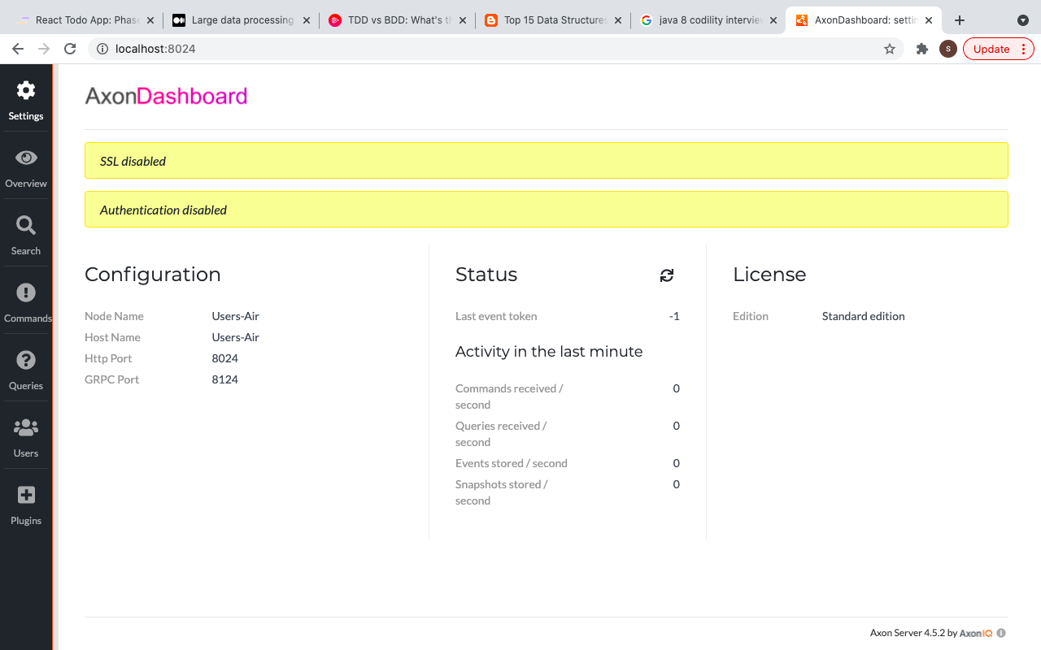

1. Like all other projects and servers, in order to use the AXON server , we have to do some configurations
2. AXON Configuration properties

<https://docs.axoniq.io/reference-guide/axon-server/administration/admin-configuration/configuration#configuration-properties>

Following properties have been added (Compare above screenshot without configurations Vs below with Configurations)

# default is 8024, I have changed

* 1. server.port=8025
  2. axoniq.axonserver.name=kunalsAxonServer
  3. axoniq.axonserver.hostname=localhost

#Button to clear event store storage - only good for development environment

#A button will appear on the dashboard

* 1. axoniq.axonserver.devmode.enabled=true > If this property is not added then the orange button below would not be shown

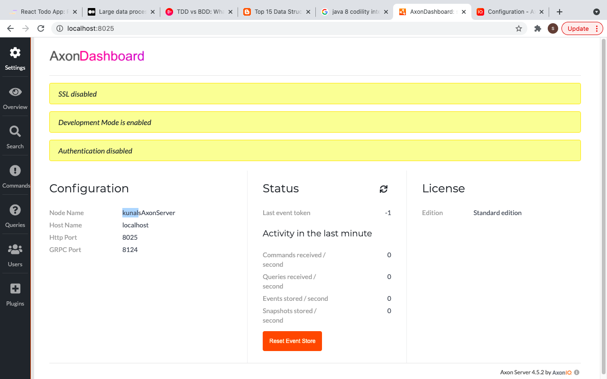

1. AXON using docker container
   1. Docker command to run the AXON server

**docker run -name -p 8024:8024 -p 8124:8124 -v pathLocalDesktop:pathOnDockerContainer imageNameInEnd_ImageName_Is_axoniq/axonserver (Complete explanation is given below)**

**Data Stores**:

* + - 1. There are different type of data stores, AXON server stores a normal data as well as event data as highlighted in light blue color, so I will make 2 directories.
    1. /data and /eventdata shown in blow color– these are basically directories in docker container , which actually contains the AXON server . **So actually there are the places where AXON server have its data stores which are residing in docker containers**

Kunal Hindi mein: Basically actually folder to hai AXON server ka, lakin hai to docker mein hi na , therefore we say right side is of docker container only

**{**

**Docker**

**{**

**AXON**

**{**

**Data-Stores**

**}**

**}**

**}**

docker run –name axonserver -p 8024:8024 -p 8124:8124

-v “/Users/user/desktop/WorkspaceSAGACQRS/docker-data/data:/data”

-v “/Users/user/desktop/WorkspaceSAGACQRS/docker-data/eventdata:/eventdata”

-v “/Users/user/desktop/WorkspaceSAGACQRS/docker-data/config:/config”

Explanations

{

🡪 Basic thumb rule : **left** to colon is local data or location **: right** to colon is docker container data or location

* + - 1. 8024 first port is for http communication

8124 second port is for PC communication

* + - 1. 8024:8024 means before colon is a port number on our computer i.e on the host machine and after colon is a port on the docker container.
      2. **-v – volume flag** = This flag is to make sure to store the value from the docker container to the local machine, so that once the container is stopped since container data gets deleted but the local data remains saved in the specified folder

Syntax : -v pathOfDirectoryOnLocalMachine:pathOnDockerContainer

* + - 1. ***Explanation per line of the docker command***
* **First line of command** -> docker run –name axonserver -p 8024:8024 -p 8124:8124
* **(AXON Data) Second Line** of command to copy docker container folder to local container so that even if the container is stopped the values are saved locally

-v “/Users/user/desktop/WorkspaceSAGACQRS/docker-data/data:/data”

* **(AXON Event Sourcing Data store) Third Line** of command to copy docker container folder to local container so that even if the container is stopped the values are saved locally

-v “/Users/user/desktop/WorkspaceSAGACQRS/docker-data/eventdata:/eventdata”

* **(AXON config properties) Fourth Line of command** to copy docker container folder to local container so that even if the container is stopped the values are saved locally

-v “/Users/user/desktop/WorkspaceSAGACQRS/docker-data/config:/config”

* (Docker-Image-name) -**Last Line**

axoniq/axonserver

**Complete command is :**

* *docker run --name axonserver -p 8024:8024 -p 8124:8124 -v "/Users/user/desktop/WorkspaceSAGACQRS/docker-data/data":/data -v "/Users/user/desktop/WorkspaceSAGACQRS/docker-data/eventdata":/eventdata -v "/Users/user/desktop/WorkspaceSAGACQRS/docker-data/config":/config axoniq/axonserver*
* *docker simply means docker container*
* *docker ps : show all the tunning containers ps is process status*
* *docker ps -a == docker continer ls*
* *docker start container id*

}

* imageName – if not present then it will be pulled from the docker hub and will be downloaded in the local machine
* -p means publish this to make the port numbers available outside of docker container means publish to our local computer. (-p=publish port)

**CQRS**

1. Make JSON object as a java object - @RequestBody us used in a parameter, no need to define setter, automatically JSON request is set to the java bean. Directly get the value

@PostMapping

**public** String createProduct(@RequestBody CreateProductRestModel createProductRestModel)

<HttpRequest –HttpMessageConverter—Java Object>

1. Put AXON entry in pom.xml

Make sure to put all these dependencies else your server will not start

<dependency>

<groupId>org.axonframework</groupId>

<artifactId>axon-spring-boot-starter</artifactId>

<version>4.5.2</version>

</dependency>

<!-- https://mvnrepository.com/artifact/com.google.guava/guava -->

<dependency>

<groupId>com.google.guava</groupId>

<artifactId>guava</artifactId>

<version>19.0</version>

</dependency>

<dependency>

<groupId>com.google.guava</groupId>

<artifactId>guava</artifactId>

<version>24.0-jre</version>

</dependency>

1. Now create a command class naming convention is

<Verb><Noun><Command> => CreateProductCommand.java, UpdateProductCommand.java,

Normally these are holder of information, and most of the time these classes are read only

**Lombok Annotations** -@builder = to initialize the fields

@data = generates getter and setters , if defined final then ->getter methods will only be generated

**AXON Annotations -** @TargetAggregateIdentifier

@TargetAggregateIdentifier -we use this when we need to load an existing aggregate, else we can // also use @AggregateIdentifier - this is mainly used when creating a new aggregate ,

// Its a kind of uniqu identifier for an event

// Aggregate is a domain object

* + - * + We are now showing an intent to do something , i.e a command has to be initiated.

1. Using a builder design pattern, we will make an instance of CreateProductCommand

// and will initialize the values

CreateProductCommand.builder().price(createProductRestModel.getPrice());

Kunal - > .builder() will allow to initialize the value using builder design pattern

CreateProductCommand createProductCommand=CreateProductCommand.builder().price(createProductRestModel.getPrice()).quantity(createProductRestModel.getQuantity()).title(createProductRestModel.getTitle()).productId(UUID.randomUUID().toString()).build();

build()-

builder() – will create a new instance of the class

Questions : aggregates ? command gateway ?

Since now command Object is created , no we have to send this to command gateway.

**Command Gateway** – Is API to sends the Command Object to Command Bus which pass it to Command Handler

**Command Bus –** It’s a mechanism to receive the command and then routs it to Command Handler

[Command Gateway]---(Sending {CommandObject})---------🡪(Command Receving mechanish)-> [Command Bus](Rout to handler)->----------------🡪[Command Handler]

Note – Command Bus dispatches a command to exactly one command handler, if there is no command handler then the error is thrown

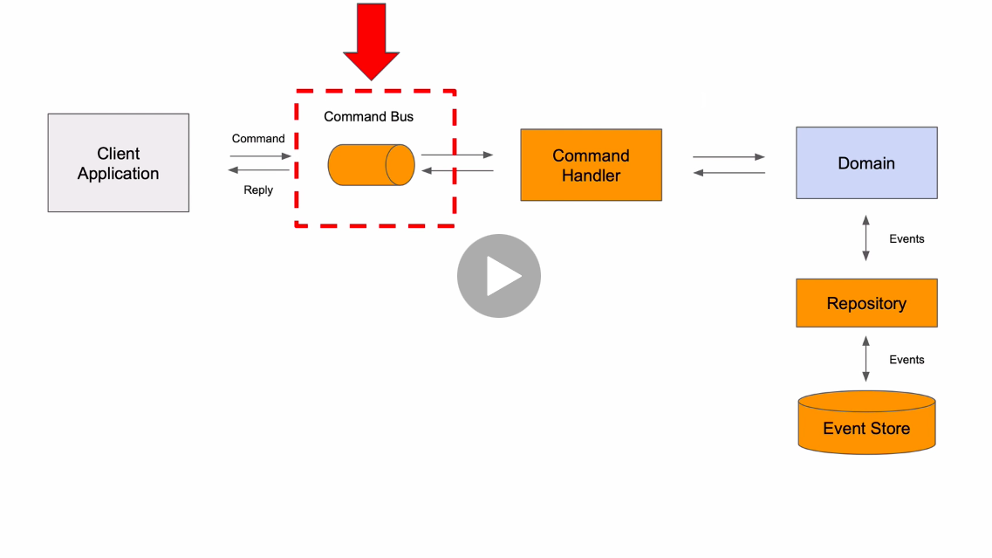

AXON Framework’s command gateway -Now command gateway has 2 methods send and sendAndWait returning completableFuture object

* + 1. **Aggregate Class –** Core of the microservice, it is a main object and holds the current state of the mail object . E.g ProductMicroservice should have ProductAggregaeClass which should hold the current state of the core object. : **hold current state – means current values**
       1. Can handle state
       2. **C**ontains methods which Can handle commands = Aggregate Class has methods to handle commands i.e commandHandlers **.**
       3. Business Logic
       4. Event Sourcing Handler methods – when these methods would be invoked whenever the information changes

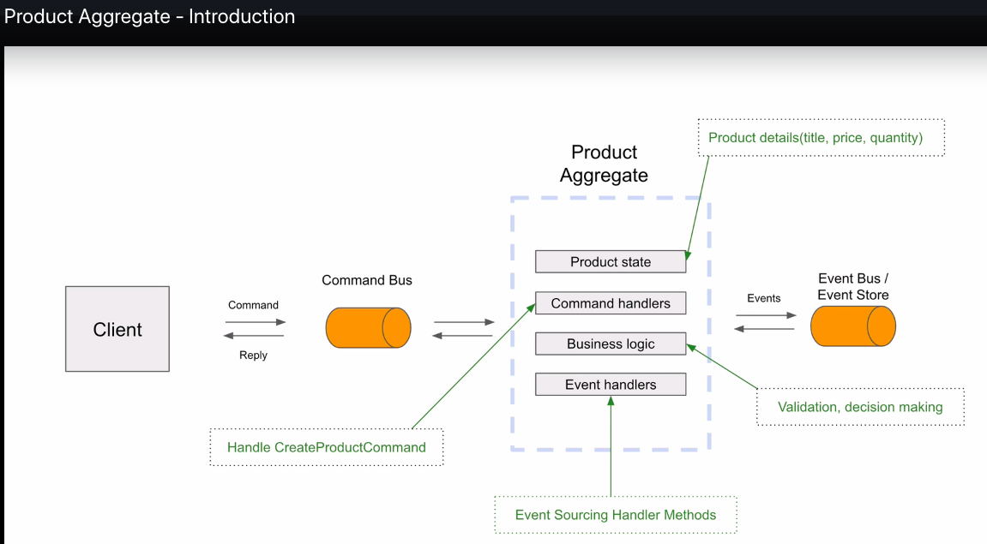

Understand is as Follows :

Aggregate Class with @Aggregate annotation– It’s a class which is associated to handle commands for a particular service or to be precise an object which has to create or modify its state , furthermore who will have series of events in event store.

Properties :

1. It will always have a no-arg constructor – Why ? because when a new service e.g product has to update its state then then entire event source is loaded from event store. Then events are replanned , based on latest updates
2. It contains 2 handlers
   * Command Handler – which gets the command from command geteway via a command bus as explained above
   * Event handler – Any change in the state leads to invocation of event sourcing , which is facilitated by event handler methods
3. It also contains Business Logic and Product State which can be new or can be updated

**Important methods and constructors of Aggregate Class :**

1. One no-arg constructor – to load executor datastore
2. @CommandHandler Anotation - Second constructor with

Parameter CommandClass i.e VerbNounCoommand, annotation @commandhandler , so whenever a new product is to be created then then this constructor will be used to create an instance.

e.g

@CommandHandler

**public** ProductAggregate(CreateProductCommand createProductCommand) {

//validate create product command – Since CommandHandler receive the receive command from CommandGateway via CommandBus , so it also validates

}

3 important components

[**Command Gateway**]---(Sending {CommandObject})---------🡪(Command Receving mechanish)-> [**Command Bus**](Rout to handler)->----------------🡪[**Command Handler**]

**Done so far** :

1. Created a product model
2. Created a command class
3. Controller
4. Aggregate class to handle commands and event services , validations and business logics
   * 1. Creating Events now – convention to make an event class **simple Past tense**

<Noune><PerformedAction><Event> => ProductCreatedEvent.java,

ProductCreatedEvent.java,

ProductShippedEvent.java,

ProductDeletedEvent.java,

We need to trigger the events once the following action is done , so the subsequent service can take an action . therefore its written in a simple past tense

* + 1. In the Aggregate class now below 3points have happened

Point 1 : Instance creation if an event - ProductCreatedEvent productCreatedEvent=**new** ProductCreatedEvent();

//copy from source to destination

Point 2 : Copy product to event , so that it can be published to be printed

BeanUtils.*copyProperties*(createProductCommand, productCreatedEvent);

Point 3: -

//Class apply method

//1. dispatch the event to all the event handlers in this class

// Once the productCreatEvent is applied to this aggregate and aggregate state is updated by new information

//then this event will be scheduled for publication to other event handlers

AggregateLifecycle.*apply*(productCreatedEvent);

EventHandler updates the Aggregate state – and are called event source in handling mathods

* + 1. private String productId; > @TargetAggregateIdentifire (In command class)and @AggregateIdentifier (In Aggregate)
    2. @EventsoursingHandler – this annotation is used on the method only to update the aggregate state
    3. Below is the flow :

Step-1 : method with annotation @command**Handler** is called , which take command as a parameter.

In this method command object is copied to the event object.

1. BeanUtils(createProductCommand,productCreatedEvent)

Step- : Call apply method so that publish can happen

1. AggregateLifeCyle.apply(productCreatedEvent)

Step-3 : Please note in the previous class only event has been copied from command to event , but actually all the values are supposed to be set to aggregate class so that event can be published. Events can be published only if the ***state of aggregate*** class is updated, which is done in method annotated by @EventSourcing**Handler**

@EvenSourcingHandler – values are set in the aggregate class now, this is called immediately after apply is called . Now the events are published to all the event handlers so that it can be consumed

***ContentHandler -🡪 EventHandler🡪AggregateObject to be published***

* + 1. Now I can see the event published on the AXON console

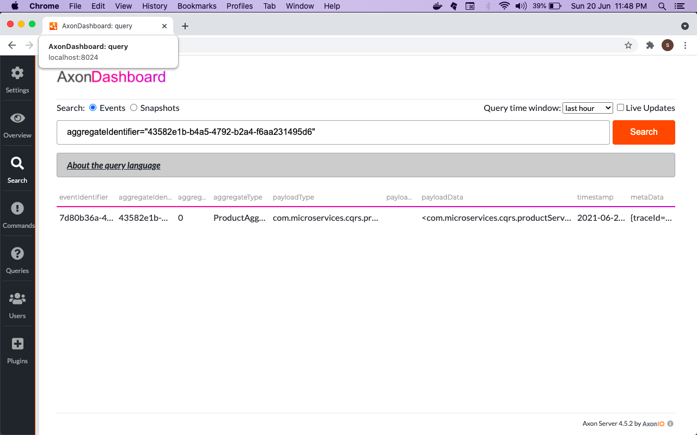

In the payload we can see the date in the xml format

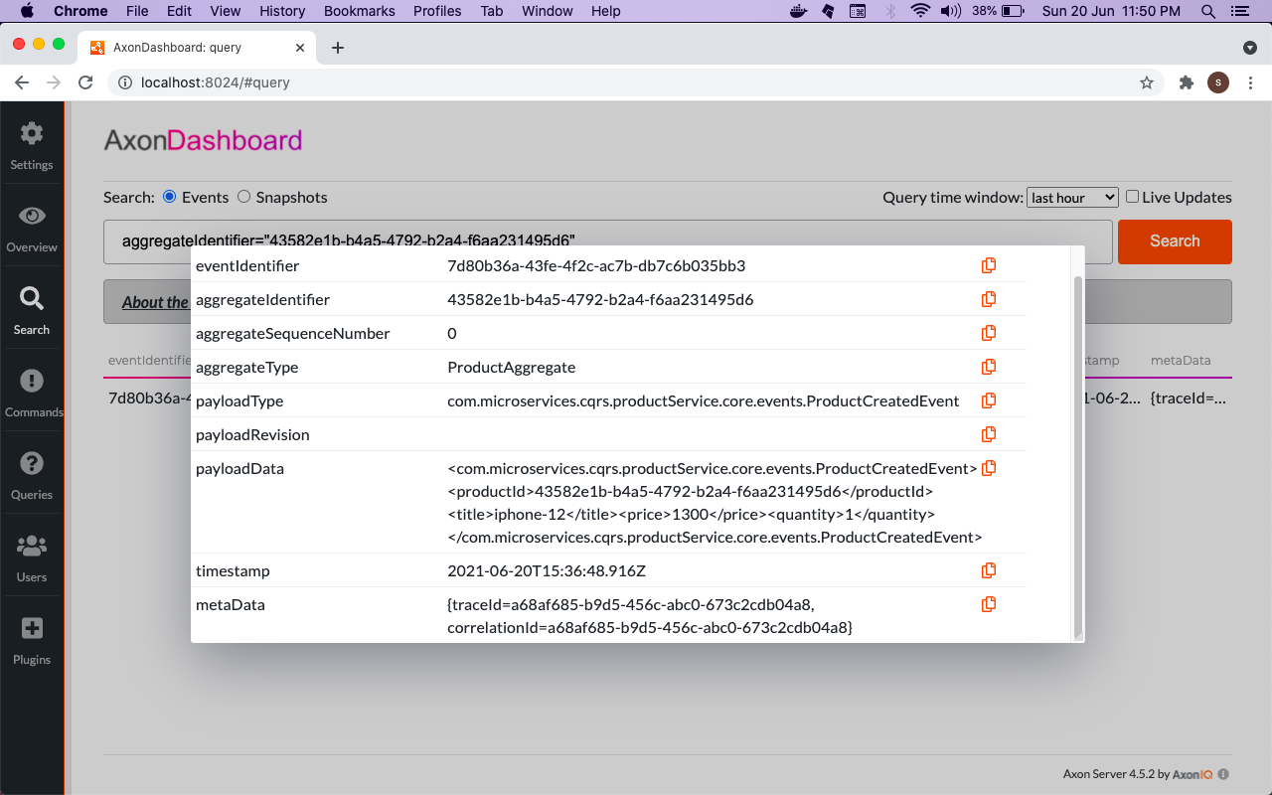

<com.microservices.cqrs.productService.core.events.ProductCreatedEvent><productId>43582e1b-b4a5-4792-b2a4-f6aa231495d6</productId><title>iphone-12</title><price>1300</price><quantity>1</quantity></com.microservices.cqrs.productService.core.events.ProductCreatedEvent>

|  |  |
| --- | --- |
|  |  |
|  |  |